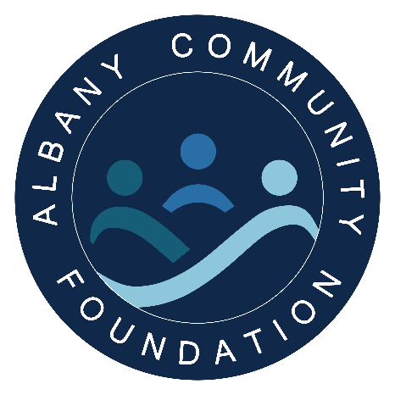

Have you ever wondered how the ACF supports your community?

As of June 2023

Individual Applications
These are individuals and families within our community who have fallen on hard times and asked for a helping hand. Key criteria of our Individual Applications are that the applicant must demonstrate they have fallen on hard times through no fault of their own and have a willingness to help themselves. Items supported must be of necessity and an identified gap in funding.

Schools, Sporting & Community Grants
The ACF partners with several local primary schools in identifying students that are facing a financial barrier to full participation in extracurricular activities including school camps, swimming lessons and leaver activities. We also partner in a similar way with local sporting clubs and community groups.

Community Rehabilitation Bike
A local crowd funded project to support Kenny, and the wider community, with the purchased of a specialised rehabilitation bike. This was asked for by the community and facilitated by the ACF!

ACF Impact Grant
This was a single $18,000 grant to the Great Southern Mental Health Network to help with the purchase of music instruments to facilitate the beginning of their “Therapy Through Music Program”. Key criteria of this grant included it being a new program which demonstrated collaboration and inclusiveness.

Cornerstone Funding

Cornerstone Applications are where existing Service Organisations make application to the ACF to request financial assistance for Individuals they are already supporting. Key criteria of our Cornerstone Funding require the agencies to demonstrate the request is for an identified gap in funding and must be for items of necessity i.e., they are essential for a basic standard of living and not available elsewhere.

For further updates on $s given back check out the home page of the ACF website.

